NETWORKING HOME LAB
PORTFOLIO
Hands-on configuration • Verification • Troubleshooting

Project 1 | MikroTik Routing and VLAN Lab
Project 2 | Ubuntu Server and WireGuard VPN
Project 3 | UniFi Wireless Network Integration
Project 4 | Cisco Packet Tracer Networking Labs

Prepared as a practical learning portfolio for entry-level Network Technician, IT Support, and Junior Network Engineer opportunities.
This document records practical lab work and the troubleshooting methods used. It distinguishes confirmed observations from incomplete work.

Project 2 — Ubuntu Server and WireGuard VPN
Linux and VPN administration | Intel NUC running Ubuntu Server

1. Project Overview
Installed and administered Ubuntu Server on an Intel NUC mini PC connected to a MikroTik hAP ac lite LAN. Practiced SSH remote administration and configured a WireGuard interface and peer settings, then investigated tunnel routing and handshake/connectivity problems.

2. Objectives
- Administer a headless Linux server from a Windows workstation using SSH.
- Inspect interfaces, IP addresses, routes, policy-routing rules, and services.
- Configure WireGuard interface and peer parameters, and manage the service with systemd.
- Troubleshoot tunnel state, handshake/transfer counters, endpoint reachability, and route selection.

3. Network Topology
Windows workstation (PowerShell/SSH) ↔ LAN/router ↔ Intel NUC running Ubuntu Server. WireGuard on the NUC is configured to connect to a remote peer endpoint. The remote peer/server is outside this project's locally controlled hardware.

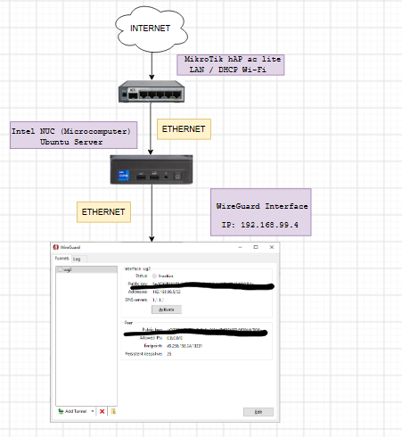

4. Configuration and Commands
The following are examples/reference commands. Adapt interface names, IPs, VLAN IDs, and device versions to the configuration you actually tested.

Inspect WireGuard state
sudo wg show
ip addr show
ip rule
ip route show
ip route get <DESTINATION_IP>

Manage the systemd service (interface name used in this lab: wg)
sudo systemctl status wg-quick@wg
sudo systemctl restart wg-quick@wg
sudo systemctl enable wg-quick@wg

Example WireGuard structure — use real keys privately; never publish private keys
[Interface]
Address = <VPN_ADDRESS>/32
PrivateKey = <PRIVATE_KEY>
[Peer]
PublicKey = <PEER_PUBLIC_KEY>
Endpoint = <PEER_HOST_OR_IP>:<PORT>
AllowedIPs = <ROUTES_TO_SEND_THROUGH_TUNNEL>
PersistentKeepalive = 25

5. Verification and Testing
- Confirm the correct interface exists and check `sudo wg show` for peer and transfer information.
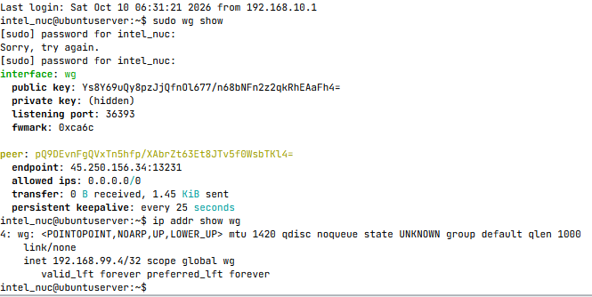
- Check service state with `systemctl status wg-quick@wg`.
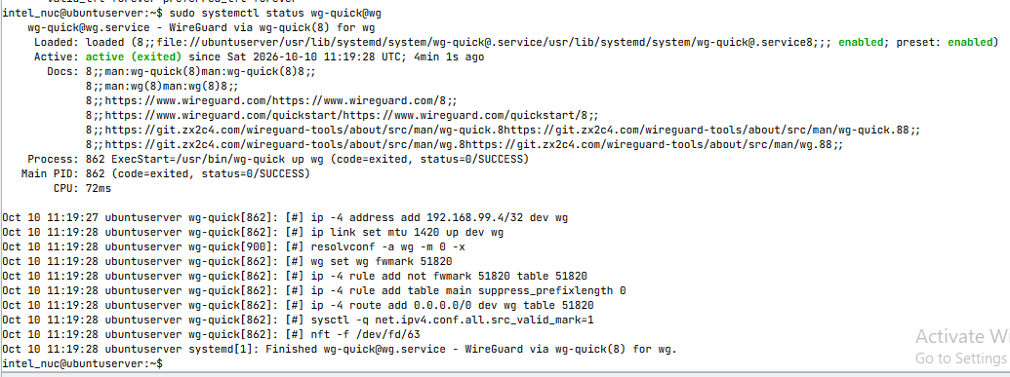
- Use `ip rule`, `ip route`, and `ip route get <destination>` to see which route will be used.
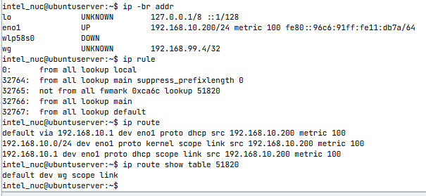
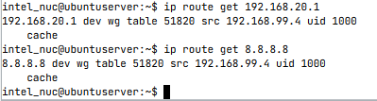
- Test the VPN peer and target network only after confirming the peer's expected routes and firewall rules.
- Compare transfer counters before and after a test; a listening interface alone does not prove a working tunnel.

6. Troubleshooting Experience
- Investigated a WireGuard state where outbound transfer was visible but received traffic remained at 0 B, and the remote gateway could not be pinged. End-to-end connectivity was not yet verified.
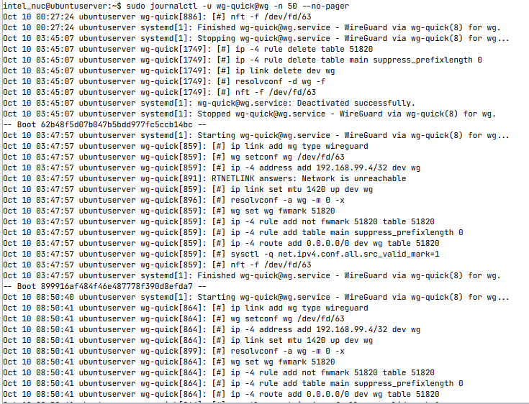
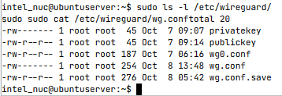
- Inspected policy-routing rules and route lookup to understand why traffic to a private gateway was being sent through the WireGuard routing table.
- Resolved an SSH known-host warning by removing the stale host-key entry and reconnecting only after verifying the server identity.
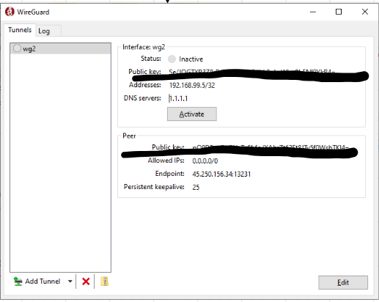

7. Final Result / Current Status
Ubuntu Server and the WireGuard service/interface were configured for practice. At the latest recorded stage, remote gateway reachability and received WireGuard traffic were still unresolved. Present this as a configuration and troubleshooting project, not as a successfully verified end-to-end VPN deployment.
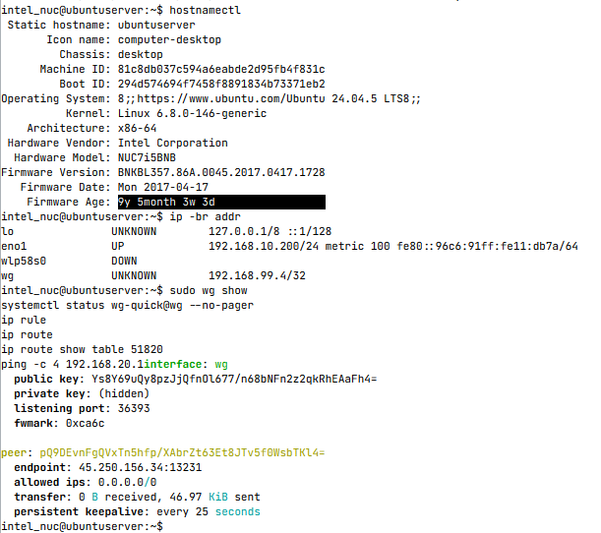
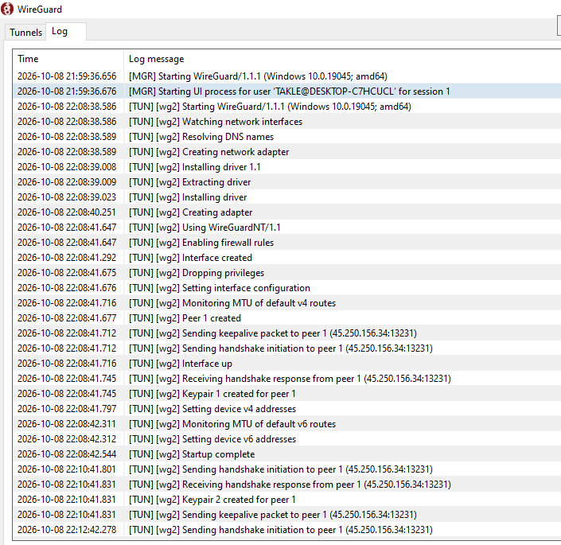
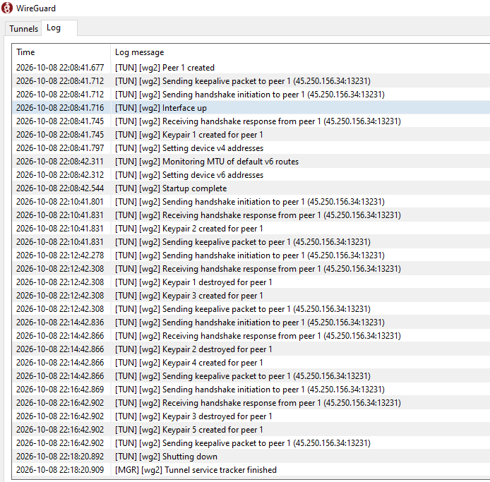

For more information about my troubleshooting experience , you may see it to my files thank you!

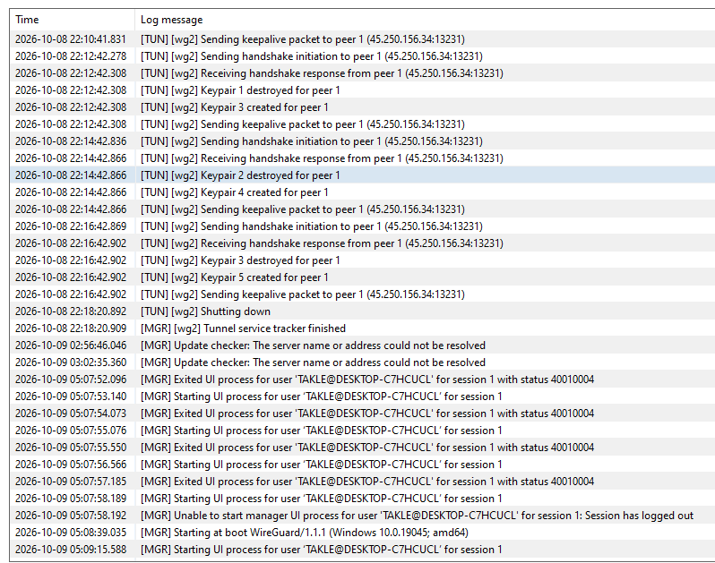

8. What I Learned
- Linux interface and route diagnostics.
- How systemd manages a WireGuard quick interface.
- Why correct keys, endpoint, AllowedIPs, peer-side routes, firewall rules, and return paths all matter.
- Why a host-key warning should be checked rather than blindly ignored.

9. Real-World Application
The same diagnostic process is useful for remote-access VPNs, Linux server support, secure administration, and remote-network troubleshooting.

10. Evidence Checklist
- Topology diagram with labels and IP/VLAN plan
- Configuration screenshot or sanitized command output
- Verification output showing successful tests
- Troubleshooting evidence: symptom → investigation → fix → retest
- Date, device/software version, and brief caption

